F O R I M M E D I A T E R E L E A S E
For further information contact: 603-362-6589, or info@paulwainwrightphotography.com

Independent Publishers Association 2011 IPPY Gold Medal Award Goes to
A Space for Faith: The Colonial Meetinghouses of New England

New Hampshire Photographer Paul Wainwright’s Leap of Faith Results in
Top Award for Best Northeast Regional Non-Fiction Book of the Year

Atkinson, New Hampshire, May 17, 2011 – New Hampshire photographer Paul Wainwright’s new book, A Space for Faith: The Colonial Meetinghouses of New England, has received the prestigious 2011 IPPY Gold Medal Award from the Independent Publishers Association as the best northeast regional non-fiction book of the year.

The Independent Publisher “IPPY” Awards were conceived in 1996 as a broad-based, unaffiliated awards program open to all members of the independent publishing industry. The awards are intended to bring increased recognition to the thousands of exemplary independent, university, and self-published titles produced each year, and reward those who exhibit the courage, innovation, and creativity to bring about change in the world of publishing.

“It's a thrilling book,” says Jim Barnes, Managing Editor & Awards Director for the IPPY Awards. “Judges keep raving about the quality of this year's entries -- even in the regional categories -- maybe especially in the regional categories, as there are so many examples of publishing passion and independent spirit among them.”

The IPPY award will be presented in New York on May 23, 2011, during the Book Expo America annual trade show. A Space for Faith previously received the New England Book Festival award for best photography/art book of 2010, and was a finalist in the New England Independent Booksellers’ 2010 book awards.

A Space for Faith was published by Peter E. Randall Publisher of Portsmouth, New Hampshire. Commenting on the book, CEO Deidre Randall said “Paul’s book was an incredible project for us, and we are very proud of the book. It was no surprise to me to learn he had won a Gold Medal IPPY.”

Ed Stevens, the book’s designer, was similarly impressed. “I was transfixed by Paul's amazingly lit photographs, and bought into the project immediately,” says Stevens. “My challenge was translating his images into the two-color duotone plates for the book, drawing on my experience in both the disciplines of silver-based photography and ink-based halftone printing. I am gratified to be a part of this beautiful book."

A Space for Faith: The Colonial Meetinghouses of New England is a collection of Wainwright’s classic black and white photographs that paints a composite portrait of these once ubiquitous landmarks of the New England landscape. Only a few remain as they were – touched only by time – and Wainwright’s photographs give us a glimpse into an age when life was simpler.

“I am extremely honored by this award,” says Wainwright. “New England’s meetinghouses embody a large part of our nation’s history, and my work photographing them was aimed at bringing their story to a wide audience.”

Wainwright’s photographs are accompanied by a Foreword by Brent Glass, Director of the National Museum of American History at the Smithsonian. Also, an essay by noted colonial-era historian Peter Benes tells about the role these buildings played in this fascinating chapter of American history.

Wainwright works with a wooden large-format camera, sheet film, and develops all his images in his darkroom. Every photograph is carefully and individually created. He prefers to create a photograph rather than “shoot” or “take a picture” and uses traditional processes which force him to slow down and really think about what he wants his images to be.

Wainwright, who had long considered himself to be a “photographer with a day job,” discovered his creative passion with his first darkroom at age 12. In 2001, when the job he had held for 24 years at Bell Laboratories was eliminated, he embraced his love of photography and re-created his life.

“I took a leap of faith.” Wainwright says, “I’ll admit that like many of us who suddenly find ourselves without a job, I was scared. But that leap of faith led me to create A Space for Faith, a book which wouldn’t exist if I’d still been working in the corporate world.” Wainwright is now a successful landscape and architectural photographer.

Drawn to capture images that reflect our Puritan heritage, Wainwright says, “They were religious dissidents who came to New England so they could live apart from the Church of England. Their lives were simple, and their belief in God was central to their lives. I believe my meetinghouse photographs reflect the Puritans’ simple, well-ordered lives and inspire my quest to simplify my own life.”

A Space for Faith may be purchased at many of New England’s independent booksellers, or securely on-line at www.aspaceforfaith.com.

# # #

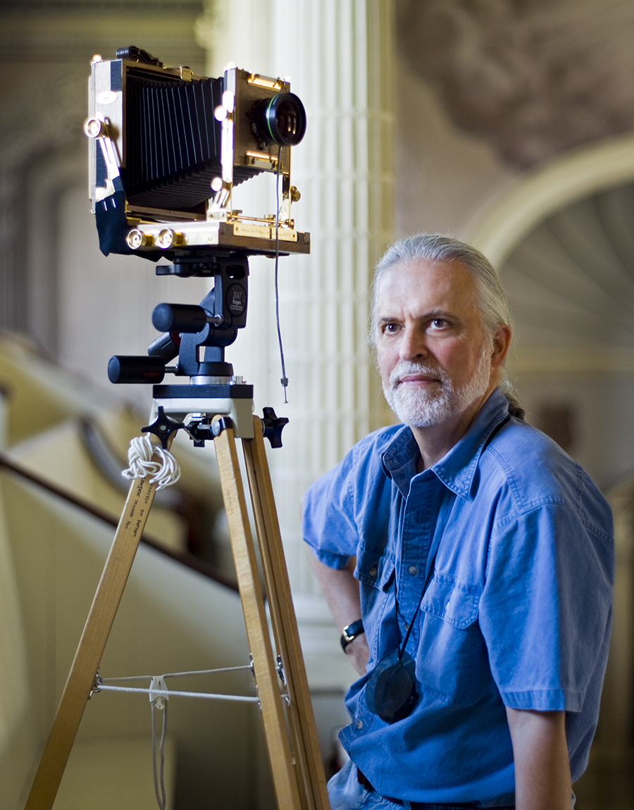
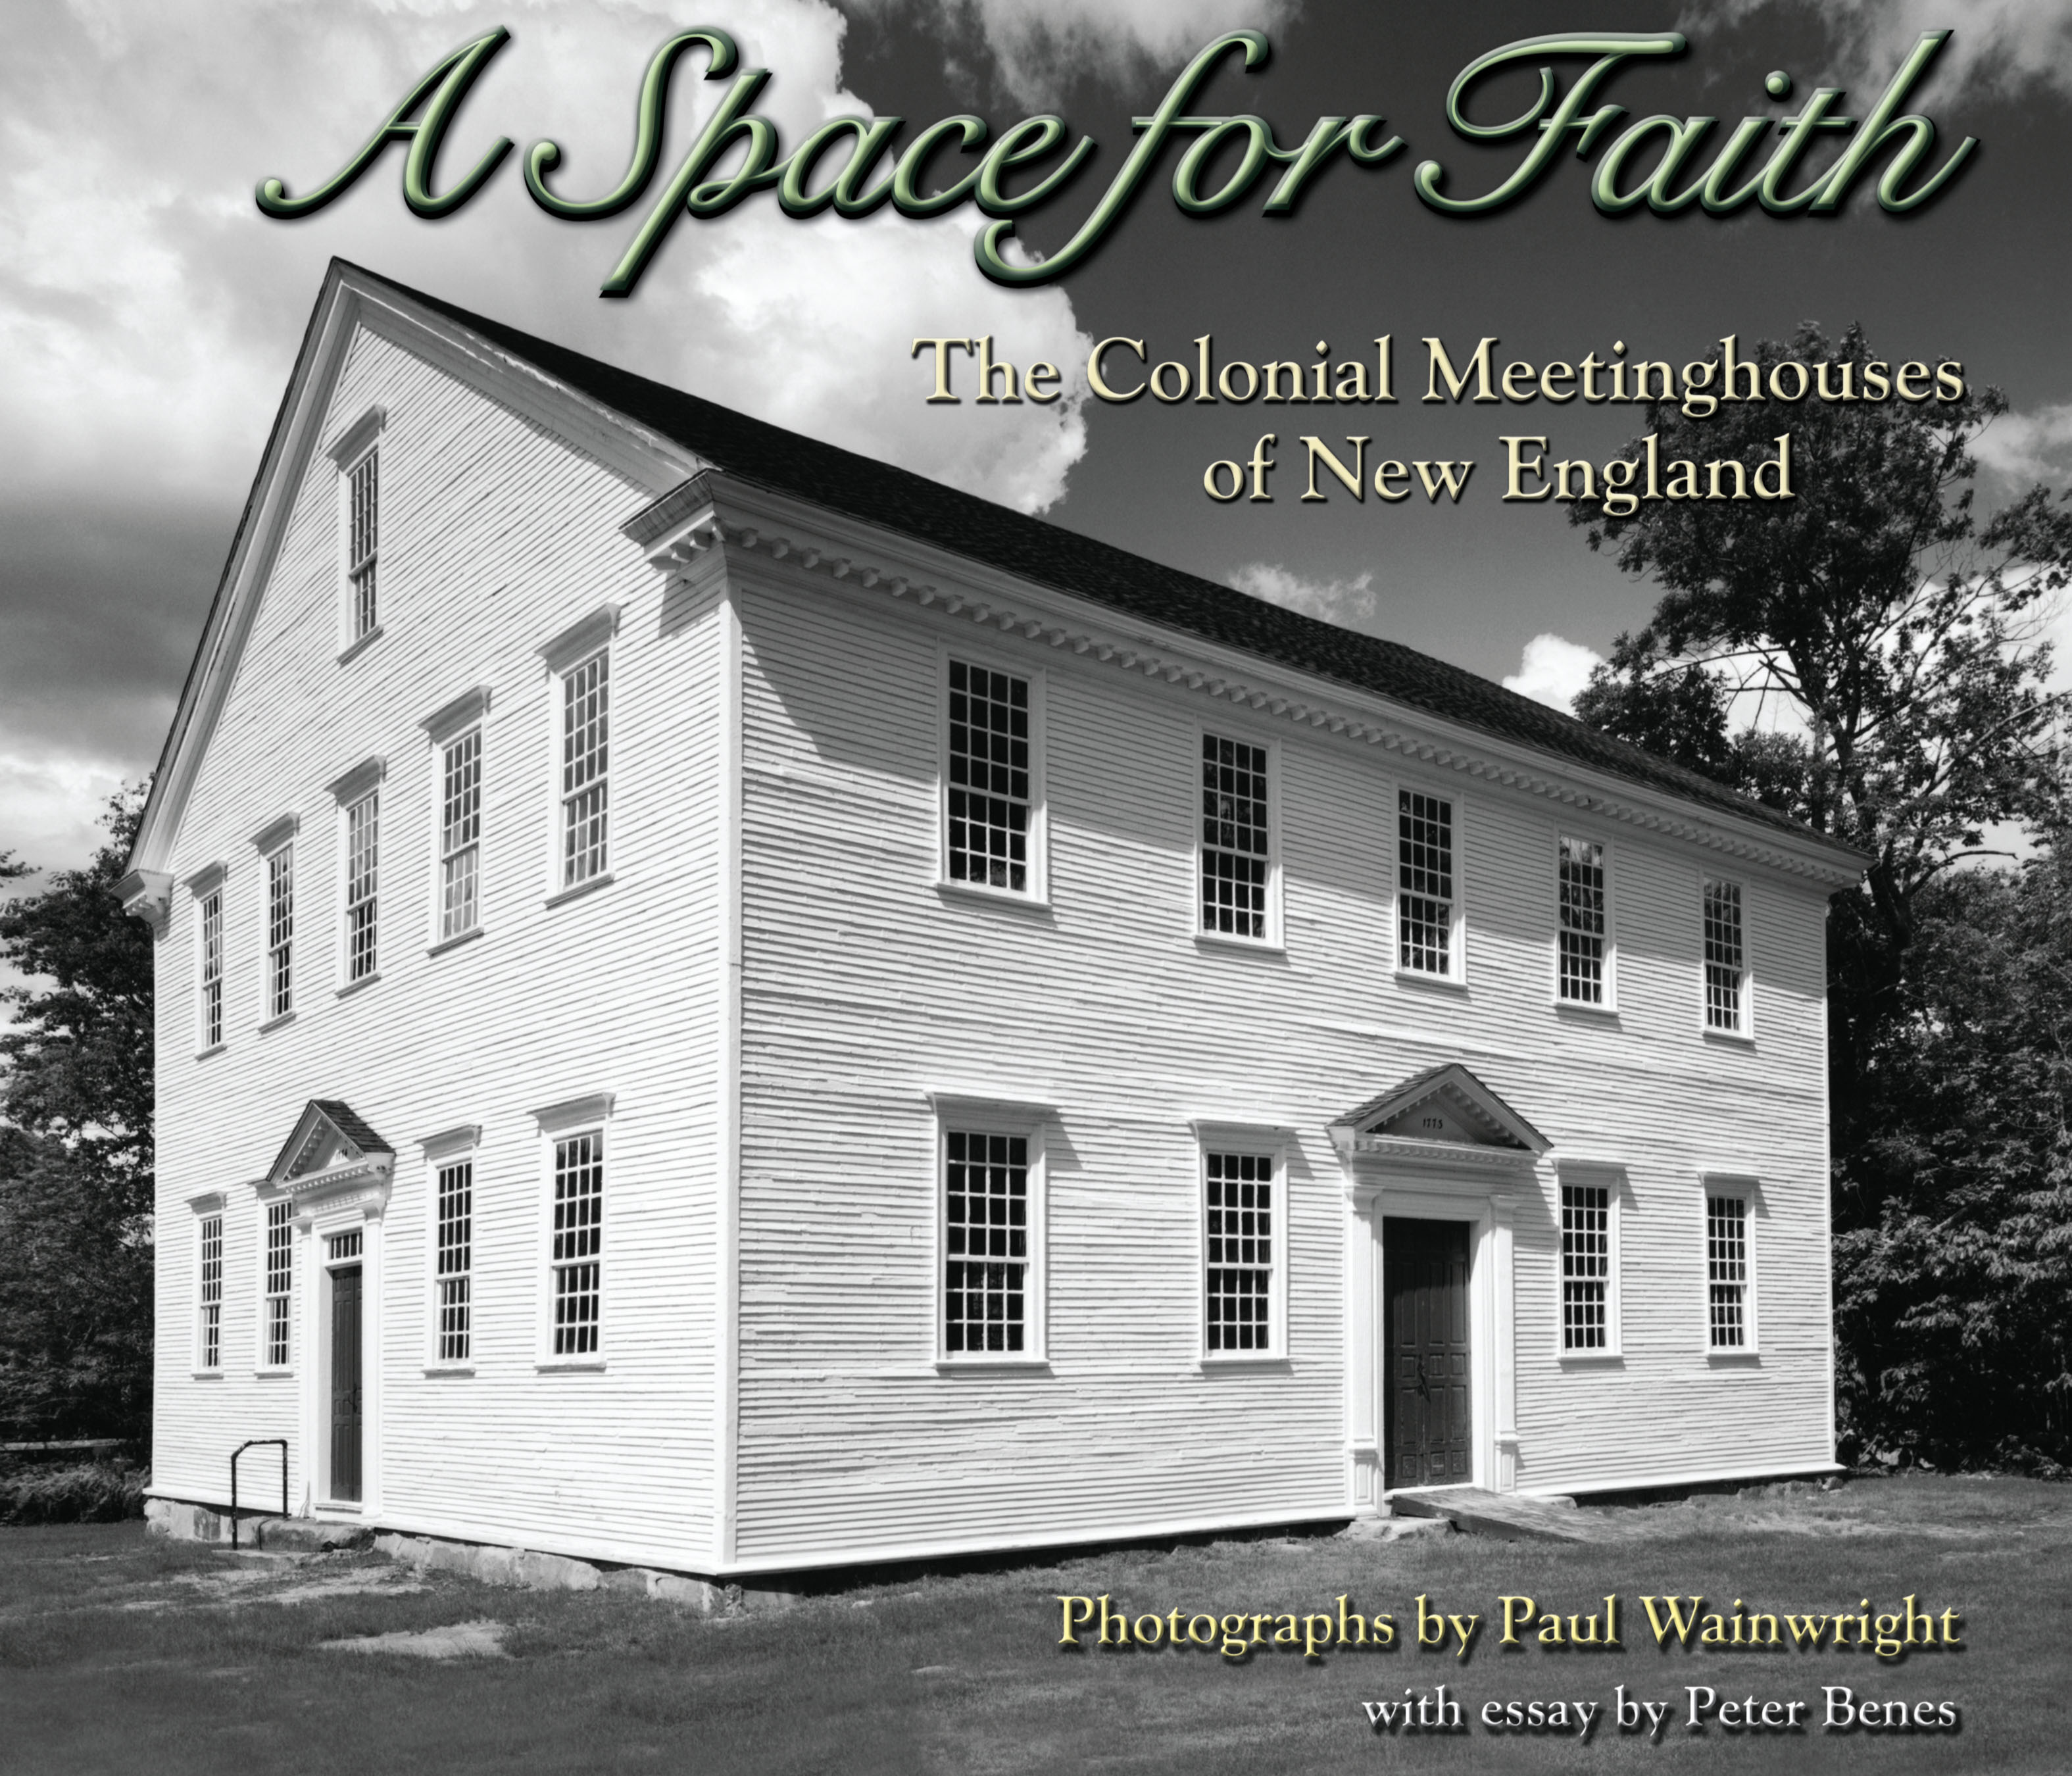

Hi-res downloads available: http://www.aspaceforfaith.com/media_room.shtml .

For review copies and author interviews, please call 603-362-6589. Additional information and photos may be found in the Media Room section of the book’s web site, www.aspaceforfaith.com.

A Space for Faith: The Colonial Meetinghouses of New England by Paul Wainwright (ISBN 13: 978-0-9817898-5-9) is published by Peter E. Randall Publisher of Portsmouth, New Hampshire.

