FOR IMMEDIATE RELEASE

For further information contact Tom Jimison, Curator, The Baldwin Photographic Gallery:
(615) 898-2085 (office), (615) 390-8544 (cell), tjimison@mtsu.edu

Gallery information and directions: (615) 898-2085

NOTE: ARTIST INTERVIEWS AVAILABLE ON MONDAY, NOVEMBER 7, 2011

A Space for Faith: The Colonial Meetinghouses of New England
on Exhibit at The Baldwin Photographic Gallery

Photographer Paul Wainwright’s Study of New England’s Meetinghouses
Tells an Important Story of Our Nation’s History

Murfreesboro, Tennessee, November 1, 2011 – New Hampshire photographer Paul Wainwright’s large-format black & white photographs of colonial meetinghouses will be on exhibit at the Baldwin Photographic Gallery on the campus of Middle Tennessee State University in Murfreesboro, Tennessee, through December 8, 2011. A lecture and opening reception with book signing will be held on Monday, November 7, at 7:30 PM.

The Baldwin Photographic Gallery is located in the McWherter Learning Resources Center at MTSU, and is open Monday – Friday 8 AM – 4:30 PM, and Saturday 12 Noon – 4 PM. The gallery is closed Sundays and MTSU holidays. The lecture on November 7 will take place in the State Farm Room of the MTSU Business and Aerospace Building, with a reception and book signing following in the gallery.

New England’s Puritan meetinghouses embody an important chapter in American history, yet their role in forming our country is not widely known. Participatory government (the “town meeting”) was born and refined in them, and the separation of church and state, enacted in the first amendment of our federal constitution, was the result of the public’s displeasure of supporting them with tax money. The original “Tea Party” was organized in one – the Old South Meetinghouse in Boston – which still stands today on Washington Street, and is part of Boston’s Freedom Trail.

Following the example set by Paul Strand in his classic 1950 book Time in New England, the exact location of each of Wainwright’s photographs is relatively unimportant. Just as Strand painted a composite portrait of New England, Wainwright’s photographs paint a composite portrait of the New England meetinghouse. These structures are typical of those that once existed at the center of every colonial New England town. While most have been torn down or renovated beyond recognition, the few structures contained in this body of work remain, touched only by time.

“These buildings are my models for making art,” says Wainwright. “Not only are they significant in American history, they are also beautiful to my eye. The textured wood and natural light that filters through centuries-old glass is a joy for me to photograph.”

Tom Jimison, Curator of the Baldwin Photographic Gallery says: “Paul Wainwright's images of the structures of New England are more than images of structures, they are portraits. They capture the same nuances, details, mood and light that a portrait photographer would. His interiors are exceptional and capture the hand crafted beauty along with the calming effect of these hallowed halls."

The Baldwin Photographic Gallery at MTSU is one of America’s premier photography galleries. The gallery has gained a reputation for showing the work of many nationally-known photographers, including Michael A. Smith, Paula Chamlee, Sally Mann, Henry Horenstein, and Keith Carter.

Wainwright describes himself as a modern-day Ansel Adams. He works with a wooden large-format camera, sheet film, and develops all his images in his darkroom. Every photograph is carefully and individually created. He prefers to create a photograph rather than “shoot” or “take a picture,” and uses traditional processes which force him to slow down and really think about what he wants his images to be.

“My work with these traditional photographic processes is a very Zen-like activity,” says Wainwright. “I think the slow, deliberate pace of creating these photographs complements the timeless nature of the meetinghouses. I find a beauty in their simplicity and austerity. My photographs are devoid of people, yet to me they are all about the people who built and used these spaces.”

Tony Decaneas, founder of Panopticon Gallery in Boston, commented: “Paul Wainwright is one of the best traditional silver gelatin printers in the country.”

Wainwright’s meetinghouse photographs were recently showcased in the award-winning book A Space for Faith: The Colonial Meetinghouses of New England, published by Peter E. Randall Publisher of Portsmouth, New Hampshire. A Space for Faith has received the New England Book Festival Award for best photography/art book of 2010, the Independent Publishers 2011 Gold Award for best northeast regional non-fiction book of the year, and the American Association of State and Local History 2011 Leadership in History Award of Merit.

In the book, Wainwright’s photographs are accompanied by a Foreword by Brent Glass, Director of the National Museum of American History at the Smithsonian. Also, an essay by noted colonial-era historian Peter Benes tells about the role these buildings played in this fascinating chapter of American history.

In his Foreword, Dr. Glass remarks: “To understand the significance of the New England meetinghouse is to understand the power and the promise of the American Dream.”

Wainwright, who had long considered himself to be a “photographer with a day job,” discovered his creative passion with his first darkroom at age 12. In 2001, when the job he had held for 24 years at Bell Laboratories was eliminated, he embraced his love of photography and re-created his life.

“I took a leap of faith.” Wainwright says, “I’ll admit that like many of us who suddenly find ourselves without a job, I was scared. But that leap of faith led me to create A Space for Faith, a book which wouldn’t exist if I’d still been working in the corporate world.” Wainwright is now a successful landscape and architectural photographer.

Drawn to capture images that reflect our Puritan heritage, Wainwright says, “They were religious dissidents who came to New England so they could live apart from the Church of England. Their lives were simple, and their belief in God was central to their lives. I believe my meetinghouse photographs reflect the Puritans’ simple, well-ordered lives and inspire my quest to simplify my own life.”

A Space for Faith may be purchased during the opening reception at The Baldwin Photographic Gallery, or securely on-line at www.aspaceforfaith.com.

# # #

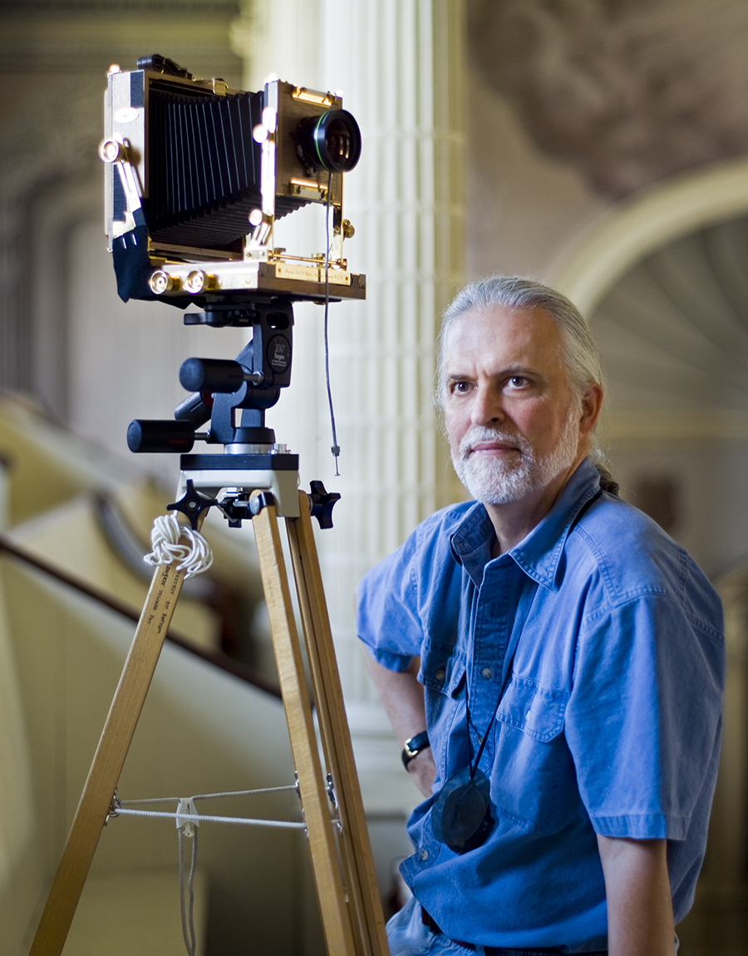
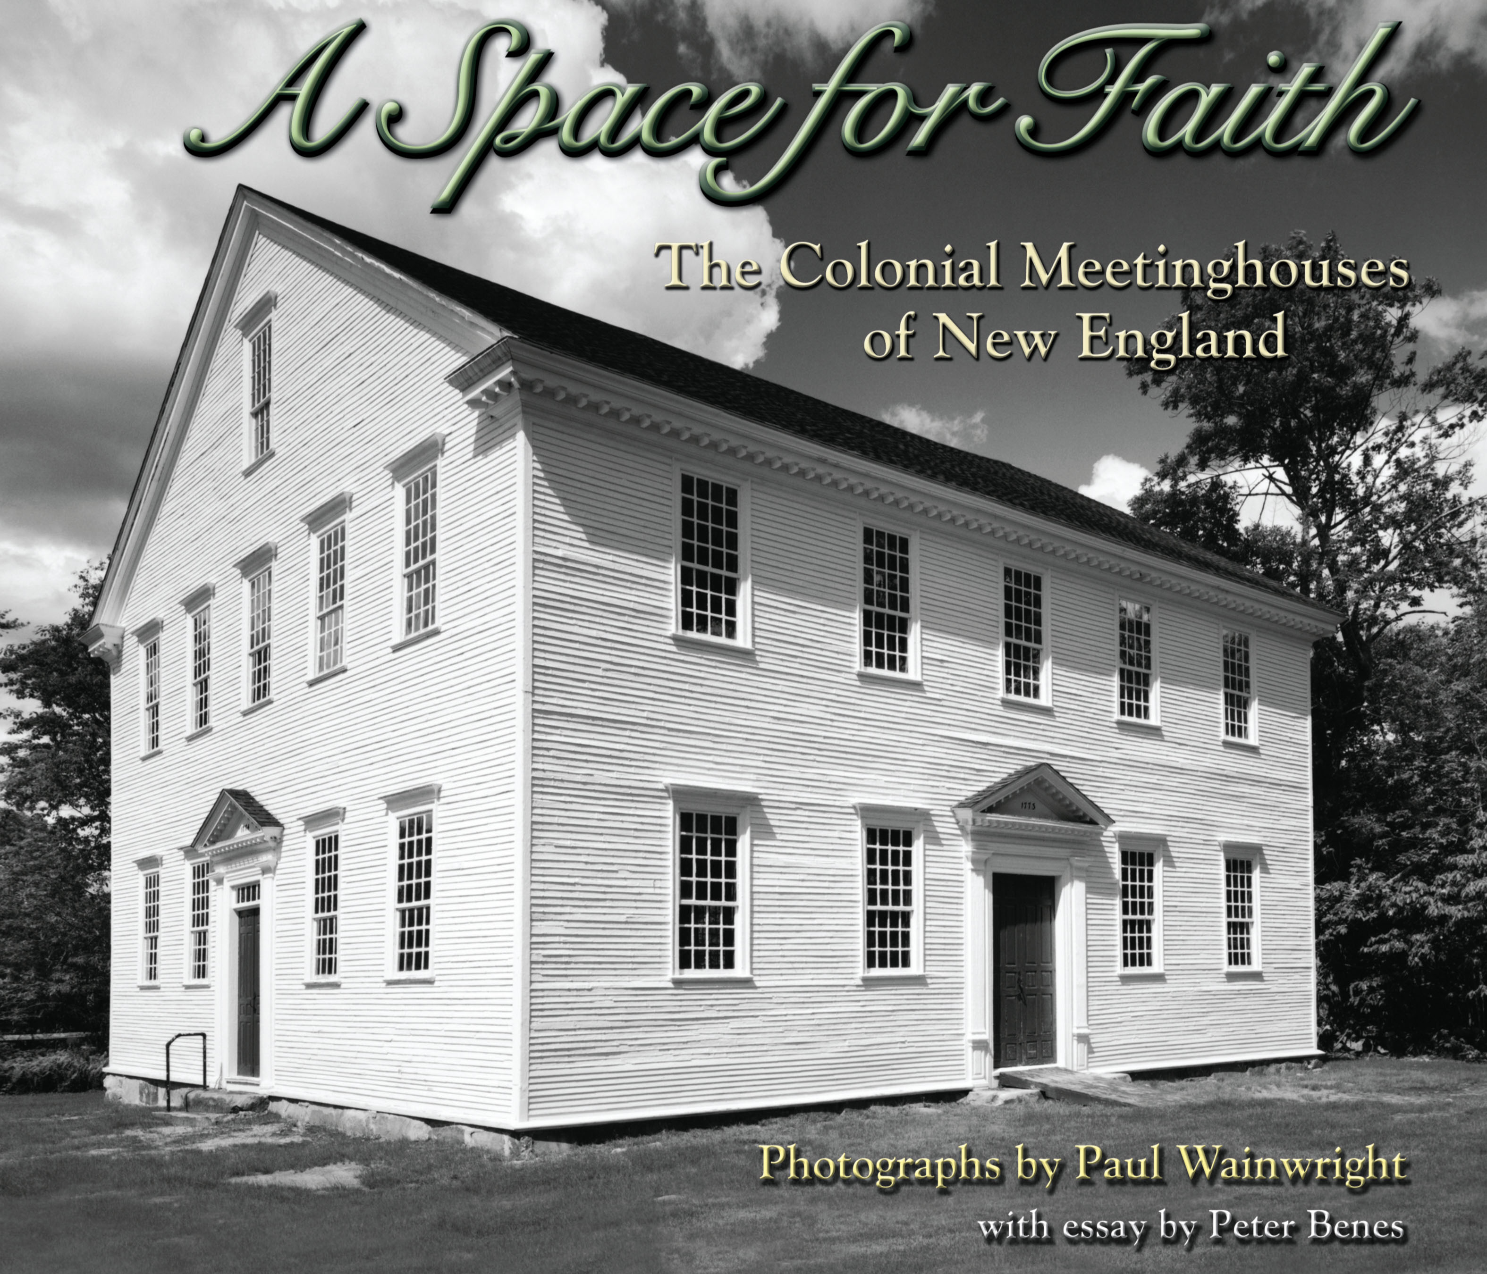

Hi-res downloads available: http://www.aspaceforfaith.com/media_room.shtml .

For review copies and author interviews, please call 603-362-6589. Additional information and photos may be found in the Media Room section of the book’s web site, www.aspaceforfaith.com.

A Space for Faith: The Colonial Meetinghouses of New England by Paul Wainwright (ISBN 13: 978-0-9817898-5-9) is published by Peter E. Randall Publisher of Portsmouth, New Hampshire.

